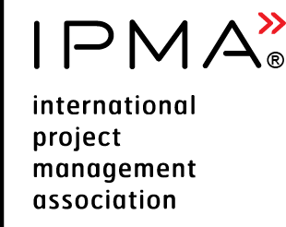 | Candidate Feedback | 

Please consider the environment before printing this document

Version control
Version and date of CVMB approval | Date | Valid until
Version A.0 | 01.07.2025 | N/A

Configuration control
Date | Version | Section | Change
01.07.2025 | A.0 | All | - Template to be used by ALL LEVELS  - Developed to be reviewed within the ICR4 Implementation project team members

Candidate Feedback
Date: ________________ IPMA Level: __ Domain __________________
Name (optional): ______________________________________________
Criteria | Evaluation
5 = Very satisfied; 4 = Satisfied; 3 = More or less satisfied; 2 = Unsatisfied;  1 = Very unsatisfied; NA = Not applicable | 5 | 4 | 3 | 2 | 1 | NA
Application
My contact with [insert CB name here] Secretariat was easy
The instructions I received from [insert CB name here] were clear
[insert CB name here] communicated with me in a clear and professional way
I had no doubts about which certification level I should apply for
Exam
The instructions I received from the exam invigilator were clear
The exam questions were clear
The difficulty of the exam was adequate to my certification level
The exam documentation was well organized
The exam logistics and the exam room environment were adequate
Simulation / Role based scenario
The activities to be performed were written / presented in a clear way
The difficulty of the simulation was adequate to my certification level
The Instructions received from the assessors were clear
The assessors treated me in a fair and professional way
Working with the other candidates allowed me to show my skills
The exercises helped me better understand my personal skills
Report
The guidelines to prepare the report were clear
Preparing the report was a good opportunity to demonstrate my skills
The report gave me the opportunity to describe my style of management
Interview / Extended Interview
The questions from the assessors were clear
The questions helped me demonstrate my skills and abilities
The site facilities were appropriate to run the interview
I was treated by the assessors in a fair and impartial way
Additional comments / suggestions for improvement
Application
Exam
Simulation / Role based scenario
Interview / Extended Interview
Other comments / suggestions

